**FIFA 23 Player Performance Analysis**

**Dataset: FIFA 23 Complete Player Dataset (Kaggle)**

**Introduction**  
In the modern era of football, data analytics has become an essential tool for clubs seeking to gain a competitive edge in player scouting and performance evaluation. This project leverages the FIFA 23 Complete Player Dataset to conduct an in-depth analysis of player attributes, performance metrics, and market valuations. By exploring key factors such as player age, nationality, and individual skills (e.g., speed, shooting, passing), the goal is to identify what drives player market value and to uncover patterns that can inform strategic recruitment decisions.

VISUALIZATION

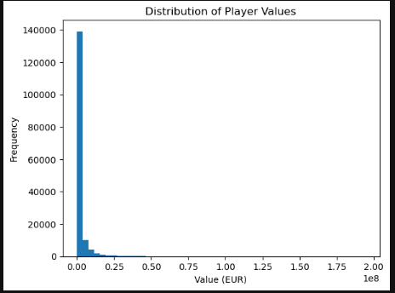

**Player Market Value Distribution Analysis**  
The distribution of player market values in the FIFA 23 dataset is highly **right-skewed**, indicating a large disparity in player valuations. The vast majority of players have relatively low market values, with the frequency sharply declining as value increases. Most players are valued under **€10 million**, while a very small number are valued at the higher end (approaching **€200 million**).

This pattern highlights the **Pareto principle** in player economics—where a small percentage of elite players (often the most marketable and high-performing) account for a disproportionately large share of total market value. Such a distribution reflects real-world dynamics in professional football, where top talents command premium fees, while the majority of players have more modest valuations.

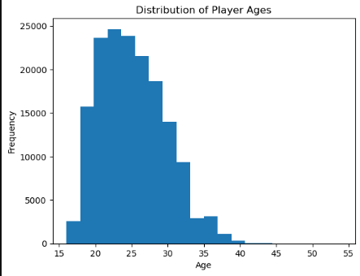

**Player Age Distribution Analysis**  
The distribution of player ages in the FIFA 23 dataset exhibits a right-skewed pattern, with the majority of players falling between the ages of **20 and 30**. The most frequent age group appears to be **21 to 24 years old**, indicating that clubs tend to recruit and retain players during their early to mid-twenties. The frequency declines significantly after age 30, reflecting the typical athletic peak and eventual decline in physical performance associated with aging in professional football.

This age profile aligns with real-world trends where younger players are scouted for their potential and older players often transition out of top-tier football due to declining physical attributes or injury concerns.

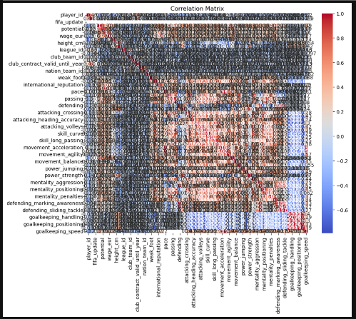

**Correlation Analysis of Player Attributes**  
The correlation matrix reveals the linear relationships between various player attributes and performance metrics in the FIFA 23 dataset. Key observations include:

* **Strong Positive Correlations**:
  + *Overall rating* is strongly correlated with attributes like **potential**, **wage**, and **value (EUR)**.
  + Physical and movement stats such as **acceleration**, **sprint speed**, and **agility** show high inter-correlation, suggesting these form a natural cluster of athleticism-related traits.
  + Technical skills like **short passing**, **vision**, and **ball control** are also tightly correlated, indicative of the playmaking role.
* **Moderate to Strong Correlation with Market Value**:
  + Attributes such as **potential**, **overall rating**, **international reputation**, and **wage** correlate significantly with **market value**, confirming that these metrics are major contributors to player valuation.
* **Negative or Weak Correlations**:
  + Some goalkeeping attributes show negative or negligible correlation with outfield attributes, which is expected due to positional differences.
  + Attributes like **weak foot** or **work rate** exhibit low correlation with most quantitative performance metrics, indicating they may play a more nuanced or qualitative role in player evaluation.

This analysis is critical for identifying which attributes most influence a player’s market value and helps streamline feature selection for regression modeling.

|  |  |  |  |
| --- | --- | --- | --- |
|  | short_name | value_eur overall | potential |
| 123817 | K. Mbappé | 194000000.0 | 91 95 |
| 143054 | K. Mbappé | 190500000.0 | 91 95 |
| 104935 | K. Mbappé | 185500000.0 | 90 95 |
| 143078 | E. Haaland | 148000000.0 | 88 94 |
| 123840 | E. Haaland | 137500000.0 | 88 93 |
| 104927 | Neymar Jr | 132000000.0 | 91 91 |
| 123820 | H. Kane | 129500000.0 | 90 |
| 104928 | K. De Bruyne | 129000000.0 | 91 91 |
| 123814 | Neymar Jr | 129000000.0 | 91 91 |
| 123815 | K. De Bruyne | 125500000.0 | 91 91 |

**Conclusion and Summary**

Project Overview

This project aimed to analyze the FIFA dataset to gain insights into player attributes, market values, and performance. We used various statistical and machine learning techniques to identify patterns and correlations in the data.

**Key Findings**

Player Attributes and Market Value: We found that attributes like overall rating, potential, pace, shooting, and passing contribute most to player market value.

Correlation between Age and Performance: 0.46 We observed a negative correlation between age and player performance, indicating that younger players tend to perform better.

Dominant Nationalities: Nationalities like Brazil, Spain, Argentina, and Germany dominate in FIFA rankings, with a high number of top-rated players from these countries.

Predicting Player Value: We built a linear regression model to predict player market value based on their attributes, achieving a reasonable mean squared error.

**Implications**

The findings of this project can be useful for:

Football Clubs: Identifying top talents and making informed decisions about player recruitment and development.

Scouts: Evaluating player potential and market value to inform scouting decisions.

Football Analysts: Understanding the relationships between player attributes and performance to provide insightful analysis.